**INTERNET AND WEB TECHNOLOGY**

**ASSIGNMENT-CO4**

|  |
| --- |
| **m.gayathri**  **1712022** |

1. **Write a JSP program to check whether a given number is Armstrong or not.**

**PROGRAM:**

<html>

<body>

<%!int n=6,temp,sum=0,rem;%>

<%temp=n;%>

<%while(n>0)

{

rem=n%10;

sum=sum+rem;

n=n/10;

}

%>

<% if(sum==temp)

{

out.println("The given number:"+temp+" is an armstrong number");

}

else

{

out.println("The number is not an armstrong number");

}%>

</body>

</html>

**OUTPUT:**

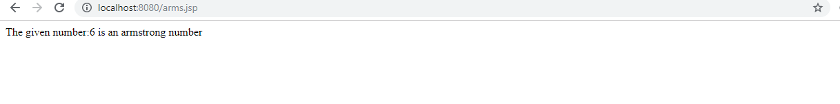

**2) Develop a code to check whether the given number is leap year or not using JSTL core tag.**

**Program:**

<%@ taglib uri="http://java.sun.com/jsp/jstl/core" prefix="c" %>

<html>

<body>

<c:set var="year" scope="session" value="${1999}"/>

<c:if test="${year%400==0}">

<p>The year is a leap year: <c:out value="${year}"/></p>

</c:if>

<c:if test="${year%400!=0}">

<p>The year is not a leap year:<c:out value="${year}"/></p>

</c:if>

</body>

</html>

**Output:**

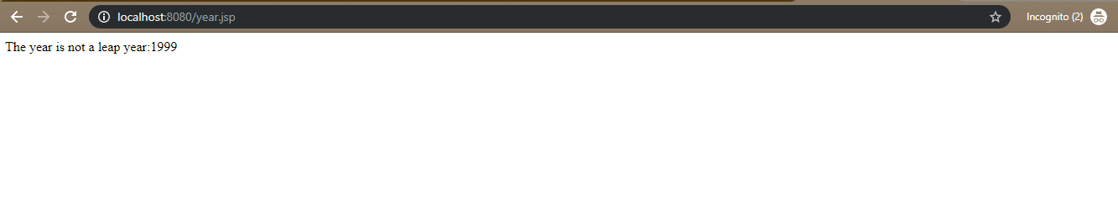

**3)Passport application form using servlet:**

<html>

<body>

<form action="insert" method="post">

<h1>online Passport application form</h1><br>

Name <input type="text" name="name"><br>

dob <input type="text" name="dob"><br>

Gender<input type="radio" name="gender" value="male">male

<input type="radio" name="gender" value="female">female<br>

PAN No <input type="text" name="pan"><br>

State <select name="state">

<option value="tamilnadu">tamilnadu</option>

<option value="karnataka">karnataka</option>

<option value="kerala">kerala</option></select><br>

Validity<input type="radio" name="validity" value="10years">10years

<input type="radio" name="validity" value="20years">20years

<br>

<input type="submit" value="submit" name="submit">

</form>

</body>

</html>

**Servlet code:**

/*

* To change this license header, choose License Headers in Project Properties.

* To change this template file, choose Tools | Templates

* and open the template in the editor.

*/

import java.beans.Statement;

import java.io.IOException;

import java.io.PrintWriter;

import static java.lang.System.out;

import java.sql.Connection;

import java.sql.DriverManager;

import java.sql.SQLException;

import javax.servlet.ServletException;

import javax.servlet.annotation.WebServlet;

import javax.servlet.http.HttpServlet;

import javax.servlet.http.HttpServletRequest;

import javax.servlet.http.HttpServletResponse;

/**

*

* @author Gayu

*/

@WebServlet(urlPatterns = {"/insert"})

public class insert extends HttpServlet {

/**

* Processes requests for both HTTP <code>GET</code> and <code>POST</code>

* methods.

*

* @param request servlet request

* @param response servlet response

* @throws ServletException if a servlet-specific error occurs

* @throws IOException if an I/O error occurs

*/

protected void processRequest(HttpServletRequest request, HttpServletResponse response)

throws ServletException, IOException {

response.setContentType("text/html;charset=UTF-8");

try (PrintWriter out = response.getWriter()) {

/* TODO output your page here. You may use following sample code. */

out.println("<!DOCTYPE html>");

String name=request.getParameter("name");

String gender=request.getParameter("gender");

String dob =request.getParameter("dob");

String pan=request.getParameter("pan");

String state =request.getParameter("state");

String validity=request.getParameter("validity");

out.println("<!DOCTYPE html>");

out.println("<html>");

out.println("<head>");

out.println("<title>Servlet insert</title>");

out.println("</head>");

out.println("<body>");

try{

Class.forName("sun.jdbc.odbc.JdbcOdbcDriver") ;

Connection con=DriverManager.getConnection("jdbc:odbc:pass","","");

java.sql.Statement stmt=con.createStatement();

String query="insert into pass values(' "+name+" ',' "+gender+" ',' "+dob+" ',' "+pan+" ',' "+state+" ',' "+validity+" ')";

int iupdate=stmt.executeUpdate(query);

if(iupdate>0)

{

out.println("<font size='14' color='blue'> Data inserted successfully</font>");

out.println("<br>");

out.println("<a href='index.html'> Click here to insert data again </a>");

}

else {

out.println("data inserted unsuccessfully");

}}

catch( ClassNotFoundException | SQLException e)

{

out.println("data inserted unsuccessfully"); }

out.println("</body>");

out.println("</html>");

}

out.println("<h1>Servlet insert at " + request.getContextPath() + "</h1>");

out.println("</body>");

out.println("</html>");

}

@Override

protected void doGet(HttpServletRequest request, HttpServletResponse response)

throws ServletException, IOException {

processRequest(request, response);

}

@Override

protected void doPost(HttpServletRequest request, HttpServletResponse response)

throws ServletException, IOException {

processRequest(request, response);

}

@Override

public String getServletInfo() {

return "Short description";

}// </editor-fold>

}

Output:

